Tutorial 2: UI Basics

Name : Chow Kui Heng

ID: 2030116-DCS

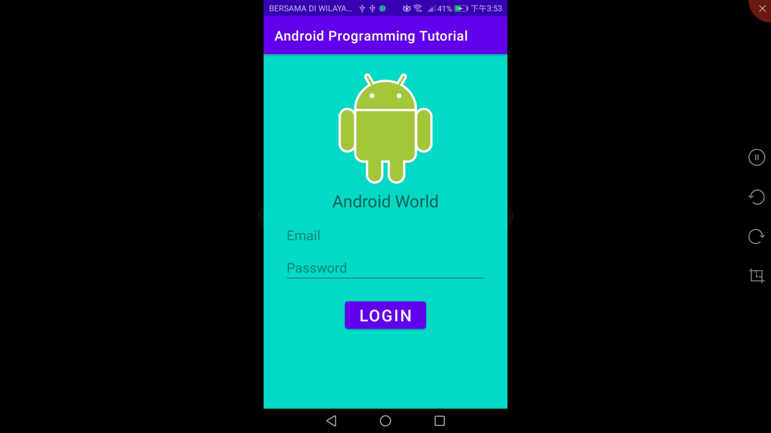

<?xml version="1.0" encoding="utf-8"?>  
<LinearLayout xmlns:android="http://schemas.android.com/apk/res/android"  
 xmlns:app="http://schemas.android.com/apk/res-auto"  
 xmlns:tools="http://schemas.android.com/tools"  
 android:layout_width="match_parent"  
 android:layout_height="match_parent"  
 android:orientation="vertical"  
 android:background=" #03DAC5"  
 tools:context=".MainActivity">  
  
 <ImageView  
 android:layout_width="180dp"  
 android:layout_height="180dp"  
 android:src="@drawable/android_logo"  
 android:layout_gravity="center_horizontal"  
 android:layout_marginTop="20dp"  
 android:scaleType="centerCrop"/>  
  
 <TextView  
 android:layout_width="wrap_content"  
 android:layout_height="wrap_content"  
 android:text="Android World"  
 android:textSize="25sp"  
 android:layout_gravity="center_horizontal"/>  
  
 <EditText  
 android:layout_width="300dp"  
 android:layout_height="wrap_content"  
 android:textSize="20sp"  
 android:layout_gravity="center_horizontal"  
 android:layout_marginTop="10dp"  
 android:hint="Email"  
 android:inputType="textEmailAddress"/>  
  
 <EditText  
 android:layout_width="300dp"  
 android:layout_height="wrap_content"  
 android:textSize="20sp"  
 android:layout_gravity="center_horizontal"  
 android:hint="Password"  
 android:inputType="textPassword"/>  
  
 <Button  
 android:layout_width="120dp"  
 android:layout_height="wrap_content"  
 android:text="Login"  
 android:textSize="24sp"  
 android:layout_marginTop="20dp"  
 android:layout_gravity="center_horizontal"/>  
  
 </LinearLayout>

<?xml version="1.0" encoding="utf-8"?>  
  
<RelativeLayout xmlns:android="http://schemas.android.com/apk/res/android"  
 xmlns:app="http://schemas.android.com/apk/res-auto"  
 xmlns:tools="http://schemas.android.com/tools"  
 android:layout_width="match_parent"  
 android:layout_height="match_parent"  
 android:orientation="vertical"  
 tools:context=".MainActivity">  
  
 <ImageView  
  
 android:id="@+id/logo"  
 android:layout_width="210dp"  
 android:layout_height="210dp"  
 android:layout_gravity="left"  
 android:layout_marginTop="15dp"  
 android:src="@drawable/android_logo" />  
  
 <LinearLayout  
 android:layout_width="wrap_content"  
 android:layout_height="wrap_content"  
 android:orientation="vertical"  
 android:layout_gravity="center_vertical"/>  
  
 <TextView  
 android:layout_width="wrap_content"  
 android:layout_height="wrap_content"  
 android:layout_marginLeft="10dp"  
 android:layout_marginTop="70dp"  
 android:layout_toRightOf="@id/logo"  
 android:text="Name: Android"  
 android:textSize="19dp" />  
  
  
 <TextView  
 android:layout_width="wrap_content"  
 android:layout_height="wrap_content"  
 android:layout_marginLeft="40dp"  
 android:layout_marginTop="100dp"  
 android:layout_toRightOf="@id/logo"  
 android:text="Age: 12"  
 android:textSize="19dp" />  
  
 <TextView  
 android:layout_width="wrap_content"  
 android:layout_height="wrap_content"  
 android:layout_marginTop="130dp"  
 android:layout_toRightOf="@id/logo"  
 android:gravity="center"  
 android:text="Course: Computer Science"  
 android:textSize="18dp" />  
  
 <TextView  
 android:layout_width="wrap_content"  
 android:layout_height="wrap_content"  
 android:layout_centerInParent="true"  
 android:layout_below="@id/logo"  
 android:text="Skills:"  
 android:layout_marginTop="70dp"  
 android:textSize="20dp" />  
  
 <TextView  
 android:layout_width="wrap_content"  
 android:layout_height="wrap_content"  
 android:layout_marginTop="100dp"  
 android:layout_centerInParent="true"  
 android:layout_below="@id/logo"  
 android:text="Make phone calls"  
 android:textSize="20dp"/>  
  
 <TextView  
 android:layout_width="wrap_content"  
 android:layout_height="wrap_content"  
 android:layout_marginTop="130dp"  
 android:layout_centerInParent="true"  
 android:layout_below="@id/logo"  
 android:text="Run Android apps"  
 android:textSize="20dp"/>  
  
 <TextView  
 android:layout_width="wrap_content"  
 android:layout_height="wrap_content"  
 android:layout_marginTop="160dp"  
 android:layout_below="@id/logo"  
 android:layout_centerInParent="true"  
 android:text="Play Music"  
 android:textSize="20dp"/>  
  
 <TextView  
 android:layout_width="wrap_content"  
 android:layout_height="wrap_content"  
 android:layout_marginTop="190dp"  
 android:layout_centerInParent="true"  
 android:layout_below="@id/logo"  
 android:text="Play Games"  
 android:textSize="20dp"/>  
  
 <TextView  
 android:layout_width="wrap_content"  
 android:layout_height="wrap_content"  
 android:layout_centerInParent="true"  
 android:layout_marginTop="220dp"  
 android:layout_below="@id/logo"  
 android:text="Do Navigation"  
 android:textSize="20dp"/>  
  
  
  
</RelativeLayout>